Join Our Team
Customizable Flyer/Poster
Recruit teammates with this customizable poster/flyer. Add your Team name or logo. Print or share digitally.
Get the Template

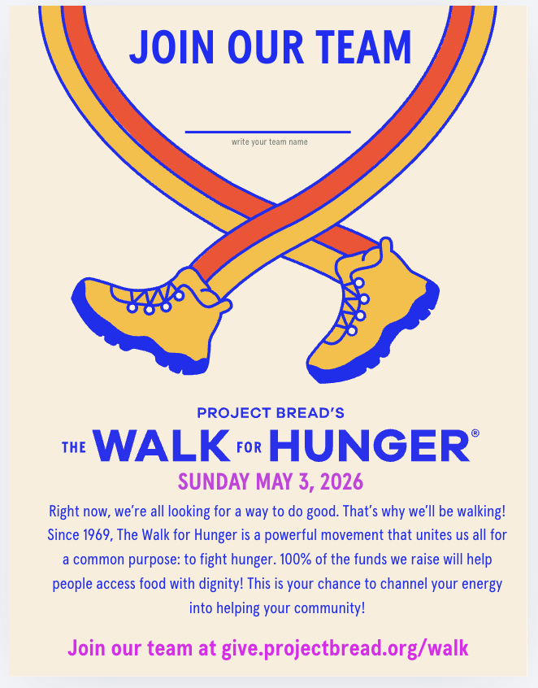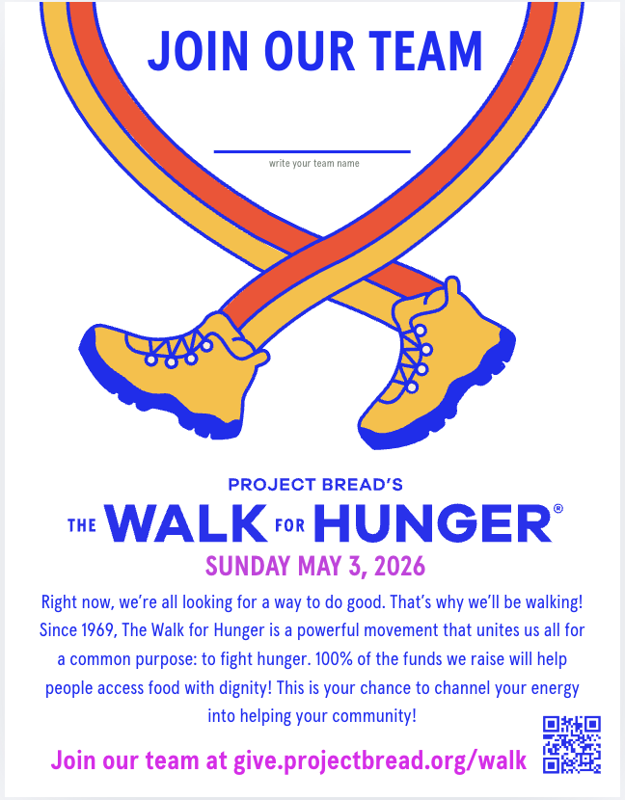
Left: solid background best for digital use. Right: print friendly version with no background

